CZECH AEROBIC OPEN 2023
PRAGUE, CZECH REPUBLIC
21st – 23rd April, 2023

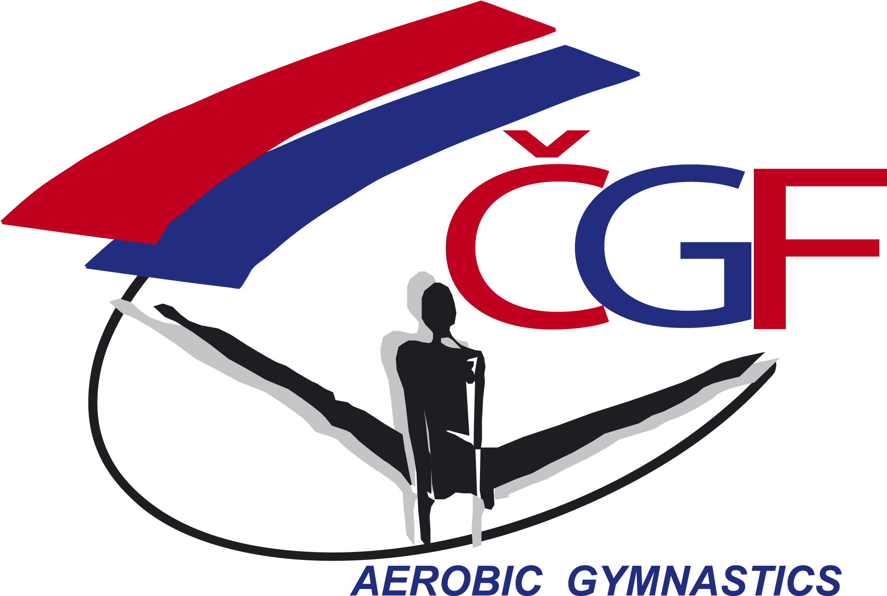

DIRECTIVES

Event ID:
Dear FIG affiliated Member Federation,

The Czech Gymnastics Federation has the pleasure to invite your Federation to participate in the aforementioned official FIG International Event.
Discipline | Aerobic Gymnastics
Host Federation | Czech Gymnastics Federation  Zatopkova 100/2, 160 17 Praha 6  Phone: +420 242 429 260, Mobil: +420 739 300 960  Email: cgf@gymfed.cz  Website: http://www.gymfed.cz
Local OrganizING COMMITTEE | Czech Gymnastics Federation  Zatopkova 100/2, 160 17 Praha 6  Contact person:  Mrs. Tereza Kočová  Phone: +420 775 664 295  Email: kocova@gymfed.cz  Website: http://www.gymfed.cz
LOCATION | PRAGUE, the Czech Republic
Date | From 21st to 23rd April, 2023
Venue | Sportovní centrum Řepy  Na Chobotě 1420/16  163 00 Praha 6, Řepy  Phone: +420 222 204 103  Email: info@sc-repy.cz  Website: www.sc-repy.cz
APPARATUS SUPPLIER | Please refer to the attached apparatus list
RULES AND REGULATIONS | The event will be organized under the following FIG rules, as valid in the year of the event, except for any deviation mentioned in these directives:  - Statutes  - Code of Ethics  - Code of Conduct  - Technical Regulations  - Code of Discipline  - Code of Points and relevant Newsletters  - General Judges’ Rules  - Specific Judges’ Rules  - Anti-Doping Rules  - Licence rules (except for non competitive events)  - FIG Framework for Safeguarding Athletes and other Participants from Harassment and abuse in Sport during Events  - FIG Medical Guidelines for FIG Competitions and Events  - Media Rules  - Apparatus Norms  - Rules for Sanctioning (approval) of International Events  - Advertising and Publicity Rules  - Regulations for Award Ceremonies  - and subsequent decisions of the FIG Executive Committee
federations invited | The Organizing Member Federation will invite all FIG Member Federations in good standing.
AGE LIMITS | JUN: 15-17 years, Seniors: 18 year and older  All gymnasts must have an FIG licence valid until the end of the event.
CATEGORIES | JUN, Seniors: IW / IM / MP / TR / GR
JUDGES AND JURIES | All judges must have a current valid FIG brevet at the time of the event, for the respective discipline.  Each participating federation must send at least 1 FIG judge. Failure to do so, will result in a fine of 500 € to be paid to the LOC until the Nominative Registration (31th March, 2023).  The number of Judge´s panels may be decided by the Organizing Member Federation depending on the number of participating competitors and judges.  The Juries will be set by a draw for the judges present at the event. The priority will be given to the judges of the highest category.
REGISTRATION DEADLINES | Definitive registration: 3rd March, 2023 7 weeks prior to the event  Nominative registration: 31th March, 2023 3 weeks prior to the event
ENTRY FEES | The Entry fees for the different categories in each Age Group are as follows:  IW & IM: 20 € / MP 30 € / TR: 50 € / GR: 60 €  100% of the Entry fee must be paid to the bank account of the Czech Gymnastics Federation on 3rd March, 2023at the latest (the deadline for the Definitive Entry).
COVID-19 | Besides the medical guidelines for the particular event, FIG also requires all the participants to follow the standard precautions.  The FIG requires all participants, judges and officials to take standard precautionary measures, such as frequent hand-washing, wearing masks or face coverings at all times and keeping a physical distance of at least 1.5 metres whenever possible.  The only situation in which the safety distance does not have to be respected is when a coach provides assistance (catch, lead, spotting) during an athlete’s performance. This phase must be kept as short as possible and the assisting person is obliged to wear a mask throughout.  Gymnasts do not need to wear a mask or face covering while they are performing at the training venue or on the FOP and keeping a physical distance of at least 1.5 metres whenever possible.  LOC is cooperating and consulting with the Czech health authorities.  All participants have to follow the Anti-Covid measurements. The Heads of the Delegations and the coaches are responsible for their delegation’s members.  Current & Extraordinary and protective measurements by Czech Ministry of Health and regional health authorities can be found on :  - https://koronavirus.mzcr.cz/en.  The rules for entering the territory of the Czech republic a list of countries with low risk of Covid-19 can be found on :  - www.mvcr.cz/mvcren/article/coronavirus-information-of-moi.aspx.
ACCREDITATION | The accreditation will take place at the venue “SC - Řepy” upon arrival of the delegations. The accreditations will be handed to the Head of delegation. Detailed information about the accreditation procedure will be given with the Work Plan that will be distributed to all participating Federations on 7th April, 2023 at the latest.
Event Format | The maximum number of units per category and nation in each Age Group category is 8, except for the Organizing Federation.  The competition consists of Qualifications and Finals in Age Groups (SEN, JUN) and all categories.  QUALIFICATIONS:  The maximum number of units per category and nation in each Age Group category is 8, except for the Organizing Federation.  FINALS:  The top 8 (eight) competitors from the Qualification in each Age Groups (SEN, JUN, AG) and category (IW, IM, MP, TR, GR, DA, ST) will take part in the Finals (maximum two per category and nation) plus 3 (three) competitors from organizing Federation in each category if they are not qualified to the finals.
PROVISIONAL Schedule | Thursday, 20th April 2023  - Arrival, Accreditation  Friday, 21st April 2023  - Training possibility, Orientation Meeting, Judges Meeting,  - Qualification  Saturday, 22nd April 2023  - Training possibility, Judges Meeting  - Qualification  Sunday, 23rd April 2023  - Training possibility, Judges Meeting  - Finals  Monday, 24th April 2023  - Departure  Detailed schedule will be made after the definitive registration.
EVENT MANAGER | Mrs. Tereza Kočová  Phone: +420 775 664 295, Email: kocova@gymfed.cz
MEDICAL SERVICES | During all days (training and competition) official medical persons will be present in the training and competition halls.
VISA | Please verify immediately with your travel agent or the Czech Republic Embassy or Consulate in your country if a visa is required for your travel to the Czech Republic. The LOC will be happy to assist each Delegation member with an official invitation letter, provided that the request is made before 3rd March, 2023 to the Czech Gymnastics Federation.  The request must include the function, full name, gender, date of birth, citizenship and passport number, passport expiry date, the arrival and departure dates of the Delegation Member as well as the city the visa application support letter must be sent to.
INSURANCE | The Host Federation, the LOC and the FIG will not be held responsible for any liabilities in case of accidents, illness, repatriation and the like.  The FIG Technical Regulations foresee that all participating Federations are responsible for making their own arrangements to have the necessary valid insurance coverage against illness, accidents and for repatriation for all the members of their Delegation.  The LOC will verify the insurance upon arrival of the delegation members (e.g. cover note or photocopy of the valid policy). Delegation members with insufficient insurance cover must inform the LOC in advance.  The LOC will subsequently offer insurance at the Federations own charge. Information about the cost of the insurance will be given with the Work plan.
INternational TRANSPORTATION | The invited participating federations must pay for the travel costs of their delegation members. The Travel Schedule Form must be returned to the LOC by 31th March, 2023. If person from one delegation/Federation are arriving and departing with different flights, please fill in separate travel forms for each group of persons and indicate on the travel form the exact number of persons.
LOCAL TRANSPORTATION | The LOC may provide transportation free of charge to all delegation members, who have booked their accommodation through the LOC, from the Prague Václav Havel Airport, Prague Railway Stations and Prague Florenc Bus Station to the their hotel and back on the official arrival and departure days.
ACCOMMODATION | Hotel Golf ****  Plzeňská 103, 150 00, Prague 5  Web: https://www.hotel-golf.cz/  The costs per room/night are as follows:  80 € (Single room, including breakfast)  110 € (Double room, including breakfast)  150 € (Triple room, including breakfast)  SKY hotel Prague ***  Ztracená 737/1a, 161 00, Praha 6  Web: https://www.skyhotelprague.cz/cs/  55 € / person including breakfast.  Available: double, triple and quadruple rooms.  *Due to the uncertain inflation situation the prices will be confirmed before definitive registration.  Hotel rooms will be allocated on a “first come, first serve” basis.  The prices charged for the hotel rooms will not exceed the usual hotel rates.  While the Provisional Accommodation Form must be returned to the LOC by 3rd March, 2023 at the very latest, the Hotel rooms will be allocated on a “first come, first serve” basis.  The invited participating federations must pay for the accommodation expenses of their delegation members.  The costs for the accommodations must be paid to the LOC as follows:  50% of the payment - 3rd March, 2023  100% of the payment - 31th March, 2023
MEALS | Lunch 20 €  Dinner 20 €  The invited participating federations must pay for the meals expenses of their delegation members.  The 100% costs of the meals must be paid to the LOC by 31th March, 2023.
CANCELATION POLICY | In case of room cancellations until 6th March 2023, the LOC will refund 100% of already payed accommodation costs.  In case of room cancelations until 3rd April, 2023, the LOC will refund 50% of already payed accommodation costs.  In case of room and meals cancellations after 3rd March, 2023, no claims of refunds will be accepted.
BANK ACCOUNT INFORMATION | Account Name: CESKA GYMNASTICKA FEDERACE  Bank Name: MONETA MONEY BANK a.s.  Bank Address: Vitezne namesti 577/2, 160 00 Praha 6  Account Nr.: 1724809504/0600  IBAN: CZ64 0600 0000 0017 2480 9504  BIC: AGBACZPP  Each participating member Federation is kindly requested to integrate the payment’s purpose as follows: CZECH AER OPEN  The participating federation is responsible for covering all bank fees in connection with the bank transfers.
Marketing | FIG advertising and publicity norms must be respected.
Media | The Media Officer of the Czech Gymnastics Federation will be present. Email: cgf@gymfed.cz  The national and local media will report the event. TV broadcast will be provided as well. More information at www.gymfed.cz
Social Media | https://www.facebook.com/CeskaGymnastickaFederace  https://www.instagram.com/czechgymnasticsfederation/?hl=cs  https://www.gymtv.cz/
DEADLINES  SUMMARY | The forms should be sent to the LOC and the Czech Gymnastics Federation as specified below within the respective deadlines.  The LOC and the Czech Gymnastics Federation: cgf@gymfed.cz  Definitive Registration 3rd March, 2023  Nominative Registration 31st March, 2023  Provisional Accommodation Form 3rd March, 2023  Nominative Accommodation Form 31st March, 2023  Meals Form 31st March, 2023  Travel Schedule Form 31st March, 2023  Visa Request Form 3rd March, 2023  Payment of the 50% Accommodation Costs 3rd March, 2023  Payment of the 100% Accommodation Costs 31st March, 2023  Payment of the Meals Costs 31st March, 2023  Payment of the Entry Fee 3rd March, 2023  Payment of the fine for missing judge 3rd March, 2023
ADDITIONAL INFORMATION | An International event for:  SEN - AD/ ST  JUN - AD/ ST  AG (12-14) - IW/ IM/ MP/ TR/ GR/ AD  ND and NG Competition: (not sanctioned) – IW / IM / MP / TR / GR  ND: AD  Age limits: NG: 6-8 years, ND: 9-11 years, AG: 12-14 years  Delegations have to prove the age of the gymnasts (FIG licence, national licence, passport, personal ID, insurance, etc.), if requested by LOC.  For ND, NG Competition only:  - There will be no qualification in age group NG and ND.  - Judges: For ND, NG Competition national judges with highest national category may be also accepted. The LOC may require the proof of the national judging brevet or ask respective NF for confirmation the national category.  Conditions, number of units, deadlines and prices are the same as for the Seniors and Juniors.  Detailed information about the program, schedules and organization of the event will be given to the Work Plan and will be send to all participating Federations after the nominative registration deadline, on 10th April, 2023 at the latest.  The Draw for the Qualifications and Finals will be done by the LOC until 17th March 2023 according to the received Definitive Entries. The Start list will be distributed to all participating Federations together with the Work Plan.

If you have any questions, please don’t hesitate to contact us.
Looking forward to welcome you to the Czech Aerobic Open 2023.
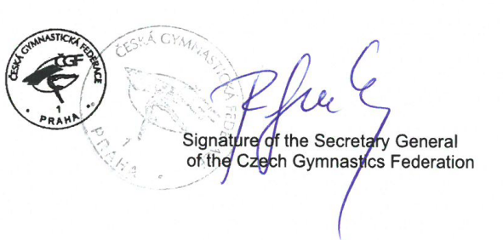
Sincerely Yours,

Prague 08. 10. 2022 Mr. Roman Slavík

