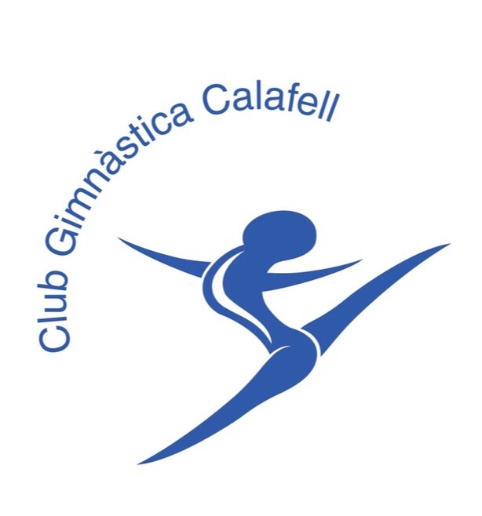**2nd Cunit International Open Competition 2025  
Aerobic Gymnastics - Age Groups & Seniors**

**Cunit - Tarragona - Spain  
 from 20th to 22th of June**

Form to be sent to:

| **Organizing Committee** |
| --- |
| CLUB GIMNÁSTICA CALAFELL  Calle del aire s/n, 43820 Calafell - Spain  Contact Person: Patricia Lopez Mobile Phone: +34 674 15 68 28  E-mail: cunitopenaer@gmail.com Website: www.clubgimnasticacalafell.com/ |

**Deadline: 1st of April 2025**

| **VISA REQUEST FORM** |
| --- |

| **Federation** |  | **Contact person:** |  |
| --- | --- | --- | --- |
| **Phone:** |  |
| **E-mail:** |  |

| **LAST NAME,**  **First name** | **Function** | **Gender**  **M/F** | **Date of birth**  dd.mm.yyyy | **Citizenship and**  **passport N°** | **Passport expiry date** | **Arrival date** | **Departure date** | **City**\* |
| --- | --- | --- | --- | --- | --- | --- | --- | --- |
|  |  |  |  |  |  |  |  |  |
|  |  |  |  |  |  |  |  |  |
|  |  |  |  |  |  |  |  |  |
|  |  |  |  |  |  |  |  |  |
|  |  |  |  |  |  |  |  |  |
|  |  |  |  |  |  |  |  |  |
|  |  |  |  |  |  |  |  |  |
|  |  |  |  |  |  |  |  |  |
|  |  |  |  |  |  |  |  |  |

| **Place and date** | **Club authorized signature** |
| --- | --- |
|  |  |
|  | Signature of the President or Secretary General of the Club |