 | Swiss Open Competition 2026  Aerobic Gymnastics | 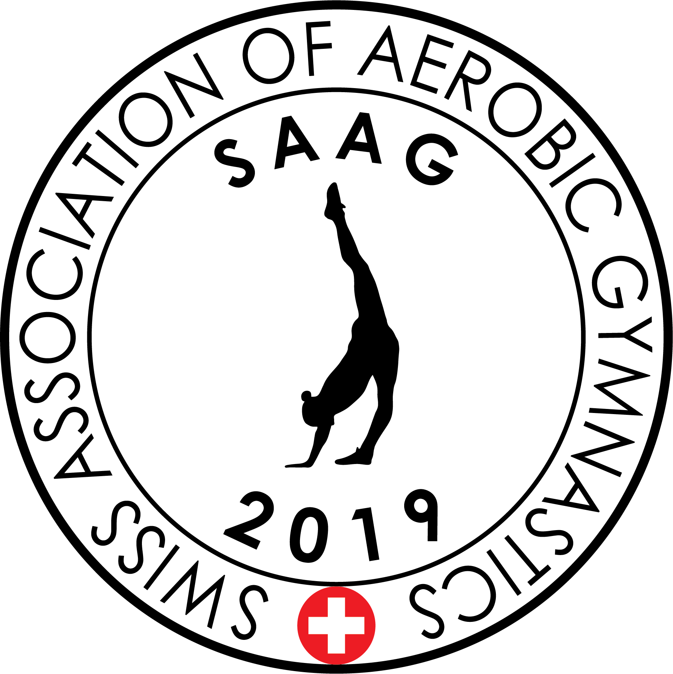

Anmeldung Athleten + Offizielle – Provisorisch
Registration Athletes + Officials – Provisional
DEADLINE: 15.04.2026

Verein/Club / Nation | Kontaktperson / Contact person
Name des Clubs
Name of the Club
PLZ/Ort, Land
Town/Postal Code/Country
Mobile
E-Mail

 | Kampfrichter  Judge | Kampfrichter  Judge
Name
Brevet

Kategorien – Anzahl  Categories – Numbers of | Aerobic Gymnastics
Kategorien – Anzahl  Categories – Numbers of | AK 6-8 | AK 9-11 | AK 12-14 | AK 15-17 | AK 18+
IW
IM
Duo / Mixed Pair
Trio
Team (4-5 Athleten/Athletes)

Kategorien  Categories | Aerobic Dance
Kategorien  Categories | AK 6-11 | AK 12-17 | AK 18+
Team (6-12 Athleten/Athletes)

Kategorien  Categories | Aerobic Step
Kategorien  Categories | AK 6-11 | AK 12-17 | AK 18+
Team (6-12 Athleten/Athletes)

Ort, Datum Unterschrift
Location/Date Signature

